**X-Ray diffraction Python**

**Part I**

The diffraction grating laser lab gives you the following data using a laser with a wavelength of 400 nm and distance from the wall of 5 m.

The distance between the diffraction maxima can be seen on the ruler. Record this distance.

The laser is moved to 7 m away from the wall. Record the distance between diffraction maxima.

The laser is moved to 10 m away from the wall. Record the distance between diffraction maxima.

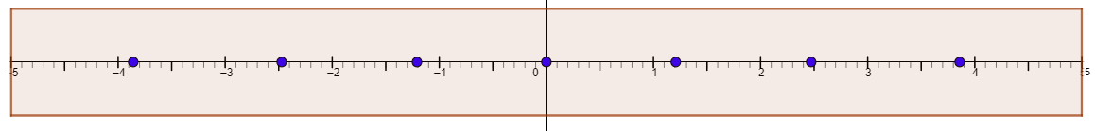

**Question 1**

Using python, find the *d*-spacing for the diffraction grating. Upload your code and take a snip of your calculation output.

**Question 1**

What is meant by monochromatic?

Using python draw two waves of light at the same amplitude, one below the other that are monochromatic. Draw separately two waves of light at the same amplitude that are not monochromatic. You may represent light waves as a simple sine curve.

**Question 2**

What is meant by coherent. Using python draw two waves of light of the samples amplitude that are coherent. Separately, draw two waves of light on the same amplitude and wavelength that are not coherent. You may represent light waves as simple sine curves.

**Question 3**

Using python, sketch the diffraction pattern you would expect to see on the screen from this diffraction grating if your laser light source simultaneously produces two different wavelengths of light, one yellow and one red.

**Part II**

Choose two of the given XRD patterns for questions 4 and 5.

**Question 4**

Plot your diffraction data with Python. Be sure to label all axis appropriately. Insert your plots here. Make sure to add tick marks for your 2theta scale from 10-80 every 10 degrees.

**Question 5**

Create a new plot simulating a 30/70 mixture of your samples with Python. It is up to you which mixture should represent 30% and which should represent 70%. Insert your plot here. Include your code for review.